|  |
| --- |
| UNITECH COMPANY |
| **DRAFT REPORT’S PROJECT INTERNSHIP PROJECT AT THE UNITECH COMPANY** |
| Topic: Event Management |
|  |
| Author: Nguyễn Thị Ngọc Ánh – PNV 19A |
| Members in the project : Quyên, Ánh, Vi (leader) |

|  |
| --- |
|  |

## Chapter 1​: Introduce about Unitech company

### Introduction

Unitech Company is built based upon finest business and process models and best practices in the IT industry, with the purpose of becoming a multi-service, multi-area corporation, effectively playing in IT and IT-related business. Unitech is the place of idea-concentration, creation-growing, gathering highly skilled, ambitious, pro-active and socially responsive specialists. Under the philosophy “United people, unique solutions”, we gather, unify talents to create superior, optimal, most effective and efficient solutions for our customers. Unitech long-term goal is striving to be a leading software outsourcing company and solution providers in Vietnam.

Location: 7th Floor – Danang Software Park, 02 Quang Trung Street, Hai Chau District, Da Nang, Viet Nam.

Email: contact@unitech.vn

### Description about company’s services

Unitech Company has a lot of products. Example: UniSpace, UniOffice, UniHospital, OAB, E – commerce - Business Across the .Net… Company focus on five services: Application development, web design and development, mobile application development, offshore development center, IT Infrastructure, software as a service. And I will introduce about two services that is strength at the Unitech Company.

#### Application Development

Unitech’s expertise lies in bellow business domain: Enterprise solutions, e- groverment, healthcare, education.

Main languages: .NET, Java, PHP

#### Web Design and development

Unitech provides the following kinds of website development service: Website, e –commerce, prortal, social network.

Quality: With Unitech’s website design and development service, it will have a good quality, fresh look, fast loading, solid data structure, high performance.

Main languages: PHP, Java.

## Chapter 2: Introduce about the internship project and project description

### Introduce about the project and the reason why we choose topic ‘Event Mangement’

#### Introduce

I have an internship project at the Unitech Company with Vi and Quyên. Before, my supervisors want to have three projects for our, but we think when we develop a project together we will learn and will have a lot of knowledge more than when we make project alone beside, we can develop our soft skills when we learn at PNV center for real working environment at the company. So, we have a unified opinion that we will make this project together. We have a lot of ideas about topic for the project, but finally, we choose topic **Event Management.**

#### Reasons

The current, everyone always focuses on develop themselves and tries to develop them skills, expand relationships, and desire to entertain. So, everyone needs a website, which has a lot of events and they can buy event tickets easily. Have a lot of potential customers want to deploy them marketing in the internet. Besides, we are becoming a PHP intern and we use Laravel Framework to develop this project. We are searching and knowing that PHP programming language usually uses to develop a lot of websites, which use to sell products online. So, we think that topic can help us about experience and knowledge when we development with PHP programming language and Laravel Framework in next time.

#### Objectives

* Helps the user to purchase event tickets easily and quickly, this is the most important and core objective.
* Sends email when a user buys tickets.
* Buys tickets with a lot of type tickets and payment
* Assign user privileges according to functions in the database
* Display menu by Function and Task of each user.

### Function of project

* Buy tickets, checkout and payment for the order
* Comment – Reply for events with AJAX
* Cart
* Search event in client page and search in admin page
* Show new events and feature events
* Users can view they orders an cancel tickets in the order before 48h
* Upload images and create a lot of type_events and create a lot of companies and create a lot of tickets when admin create a events
* Display menu by function and task of each user (user_action, user_group, menus)
* Show and download attached files

## Chapter 3: Working environment

### Project realization and IT experiences

In this project, my task focuses on admin management pages, design layout client, design layout admin and design database.

#### Design database

#### I analyze and list all tables that I think I need, and I analyze all relationship between tables. And then I have a meeting with my team and unified opinion to finish database that we think it good for our project.

Experiences when I design database. Sometime I have some wrong opinions for some relationships between some tables. I think it will have a relationship 1- n but, in fact it will have a relationship n- n, so I have an experience, when I think about a problem to find solution, I need to read documents and ask supervisors to make a conform database. When I migration tables in the Laravel Framework, Don’t add foreign key for tables. Because when I add foreign key for table, I will have a lot of difficult problem when delete a data in the table and a lot of another difficult problem.

Result: 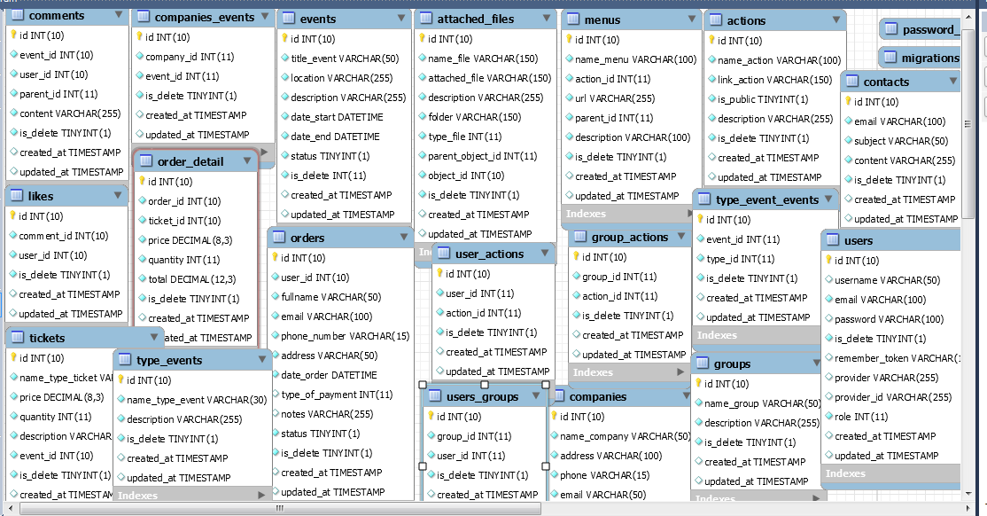

#### Design layout admin and layout client

I design layout for client pages and admin pages. I think when we make a website project, we need to have a good layout and it need to conform to topic of website.

Experiences when I design layout admin and layout client. When I design a layout, I think font and color coordination is important to make a good website, so when I design a layout, I need to think and find color and font conform for the website.

Result: 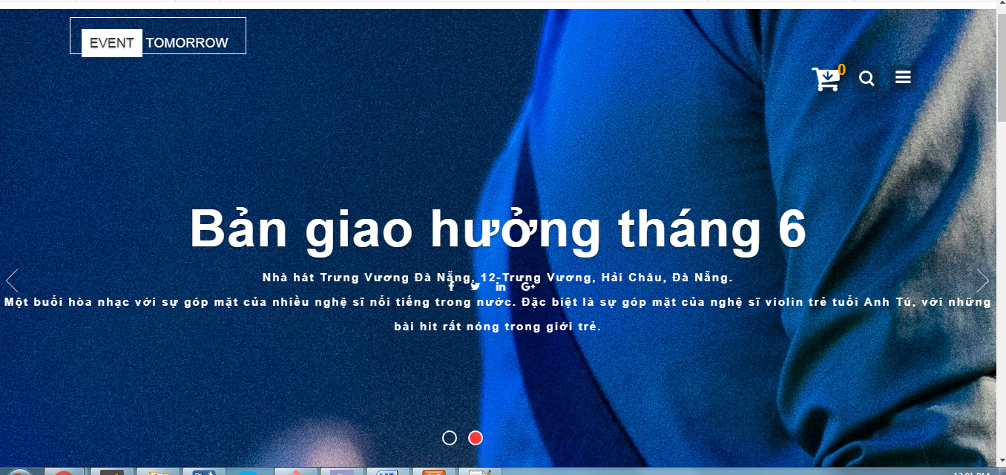 Header in index page

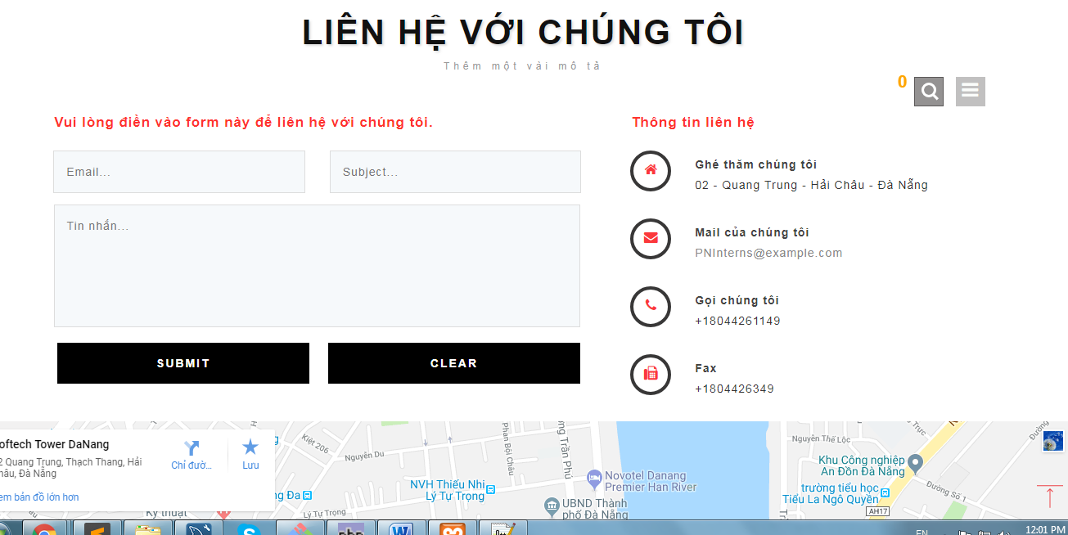Contact Page

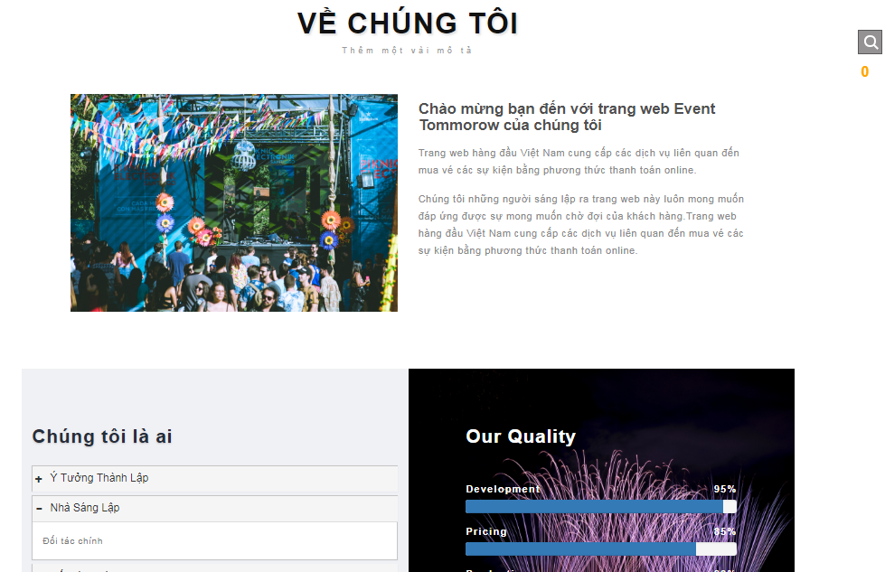

About page

#### Admin management

I make all of function in admin management.

Experiences when I manage admin page. Before, I think when I manage admin page, I need to add, create, edit and show information from a table in database and I will finish my task, but when I intern in company, my supervisors say that, when I manage admin page, I need to use all relationship of the table to show, edit, create and short data from database. Example, when I add an event, I need to add company, type_event, and tickets at the same time.

Result: 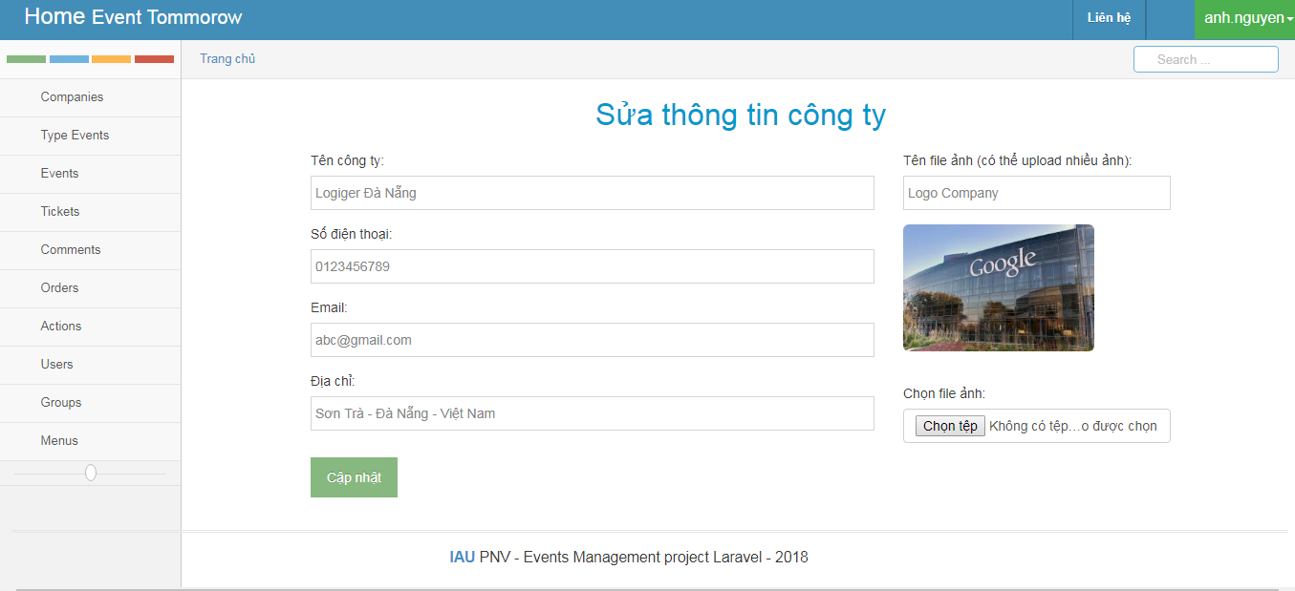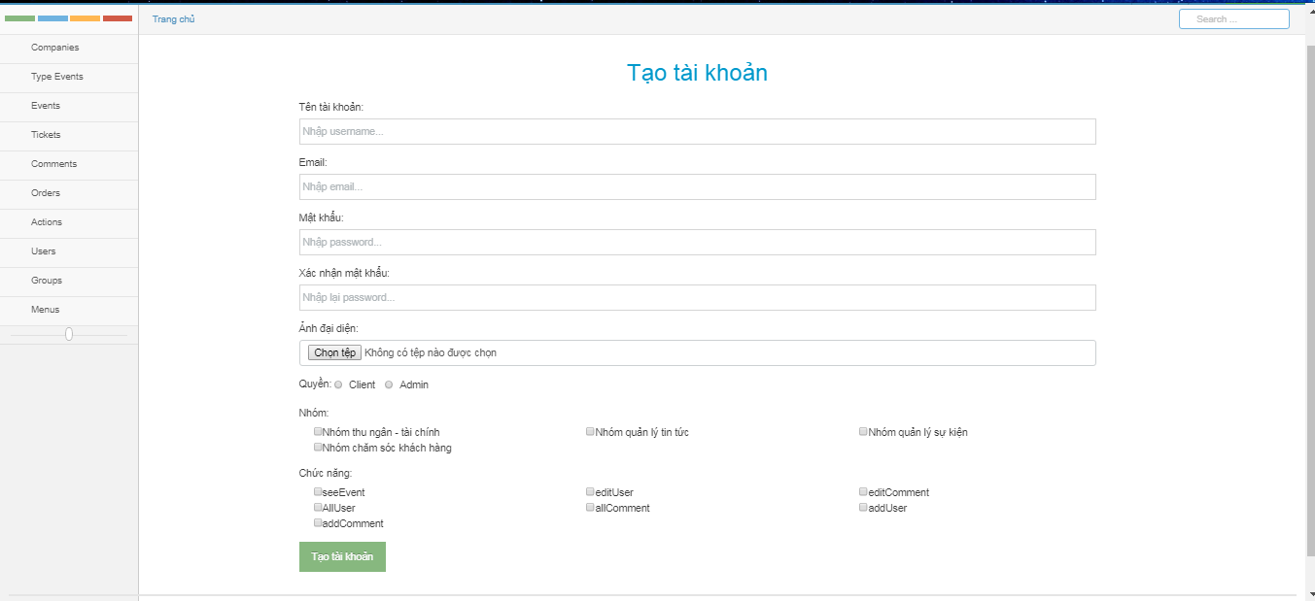

### Day to day work and analysis

### Soft skills related experiences

#### Debate

When we start to design database and list all function we will develop in this project, we have a lot of problems. Before I have not worked in a team with Vi and Quyên and we have learned at PNV center with another IT teacher, so we didn’t have unification opinions in ideas and thinking.

Example: When we analysis and design database, we have a bigger problem about relationships between the event table and the ticket table. We didn’t have a unified opinion for this problem, and then we have a meeting to find a solution to solve this problem. Everyone in my team will present them opinion and they thinking, I am listening and think, I present about my opinion and give my members a lot of examples for my members, try to explain and convince people in my opinion.

#### Solving Problem

I am a student with my major is information technology so, solving problem is important when I develop a project. When we have a problem about technical or find solution for some difficult function. We need to have thinking logic and analyze problem to find solutions. When I have a good solving problem skill I can help my team don’t have conflict between temmebers.

## Chapter 4​: Conclusion

### 4.1. Achievements

### 4.2. Conclusion

### 4.3. Reflection on career path